Visualisation Report
Analysis of Covid-19 chest x-rays

Anne Ast, Waldeiton Moreira, Philipp Schaz, Tanja Schröder

18.07.2024

- Overview of the Data

The primary data was obtained from the COVID-19 Radiography Database that is available on Kaggle (COVID-19 Radiography Database). The data was created by a team of researchers and medical doctors from Qatar University, University of Dhaka, and collaborators from Pakistan and Malaysia. The X-ray images were collected from various publicly accessible sources, online datasets, and published articles. The images are stored in PNG (Portable Network Graphics) format with a resolution of 299x299 pixels.

The dataset has a total of 21,165 images distributed across the following categories or classes:
- Normal: 10,192 images of healthy individuals without any pulmonary anomalies. These serve as a control group for comparison with other classes. 10,192 images
- COVID-19: 3,616 images of patients who tested positive for COVID-19. These images are crucial for identifying specific patterns associated with COVID-19 infection.
- Lung Opacity: 6,012 images of patients with non-COVID-19 lung infections, helping to differentiate between different types of lung opacities.
- Viral Pneumonia: 1,345 images of patients with viral pneumonia, used to differentiate between non-COVID viral infections and COVID-19 cases.

- Data quality
In this step, the quality of the data was examined in terms of the readability of both images and masks, the correctness of the image and mask labels, and the uniformity of the image and mask sizes. Additionally, it was checked whether the data contained duplicates, meaning if certain images appear multiple times.
As part of the readability check, it was verified whether all images (including masks) could be read or loaded, or if there were any corrupted images. It was found that all images could be read. The correctness of the labels was checked by comparing the correct label format, which consists of the case (Covid, Normal, Viral Pneumonia, Lung Opacity), a hyphen, and a one- to five-digit number, with the labels of the images. It was found that all images were correctly labeled. In another step, it was examined whether all images had a uniform size. The target size was 299 x 299 pixels for the X-ray images and 256 x 256 pixels for the masks. It was confirmed that all images were of a uniform size. The following figure shows the output of the examination, summarizing the results of the just described quality check.
Figure 2.1: Summary of the results of the quality check
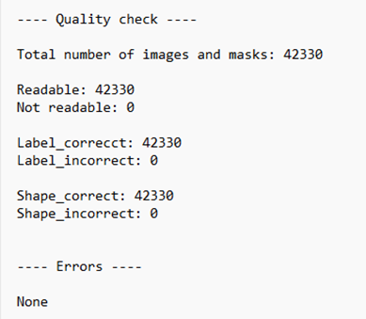

As the images were curated from many different sources, some of which were data collections/repositories themself, we checked the dataset for potential duplication of images. In order to do so, we generated a data frame containing descriptive statistics (count, mean, std, max, min, median, q25, q75, skewness, kurtosis) and meta information (image name, image path, class/label, URL of the source) for each image. Under the assumption that two images are very likely to be the same, if the descriptive statistical data is identical, we first compared descriptive statistical data of the images with each other. We found 59 putative duplicates. In a second step we compared the actual image arrays among the potential duplicates in a pairwise manner and found that images are identical. Exemplified images are shown in Figure 2.2.
We found a tiny minority of images that appear in duplicates, which we will exclude from our analysis, in order to reduce redundancy.

Figure 2.2: Examples of duplicated images
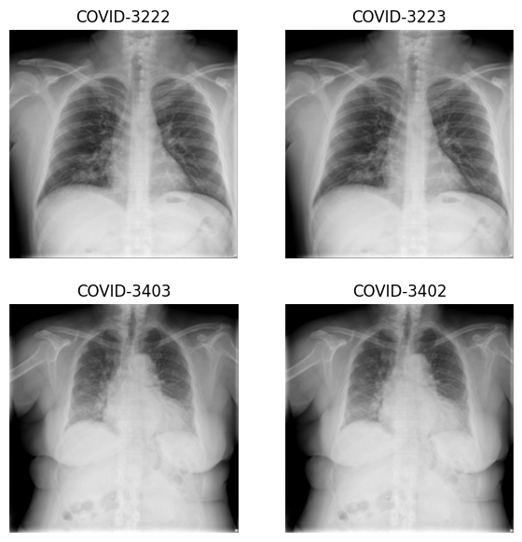

- Data composition

In this chapter, we analyzed the number of images per class (Covid, Normal, Viral Pneumonia, Lung Opacity) detailing how many images were collected from which source within each class.
We utilized the data frame described above to group the images according to their respective class and source and plotted the data as a stacked bar diagram (Figure 3.1). We observed that all classes are represented by a different number of images (Covid = 3616, Normal = 10192, Viral Pneumonia = 1345, Lung Opacity = 6012). This means that certain classes are over- or underrepresented in our dataset. We will take this into account when preparing the training data (resampling) and when choosing the model.

In addition, we found that the images of lung opacity and viral pneumonia cases each came only from one source, whereas normal lung images were collected from two sources and images from COVID cases were collected from 6 different sources. This might mean that the images depicting lung opacity cases are more homogeneous, in comparison to the images depicting COVID cases. Given that we are dealing with images from many different sources, normalization of the images is advisable in order to compensate for potential differences in brightness that might occur if the images are taken at different hospitals with different equipment.

Figure 3.1: Composition of the dataset

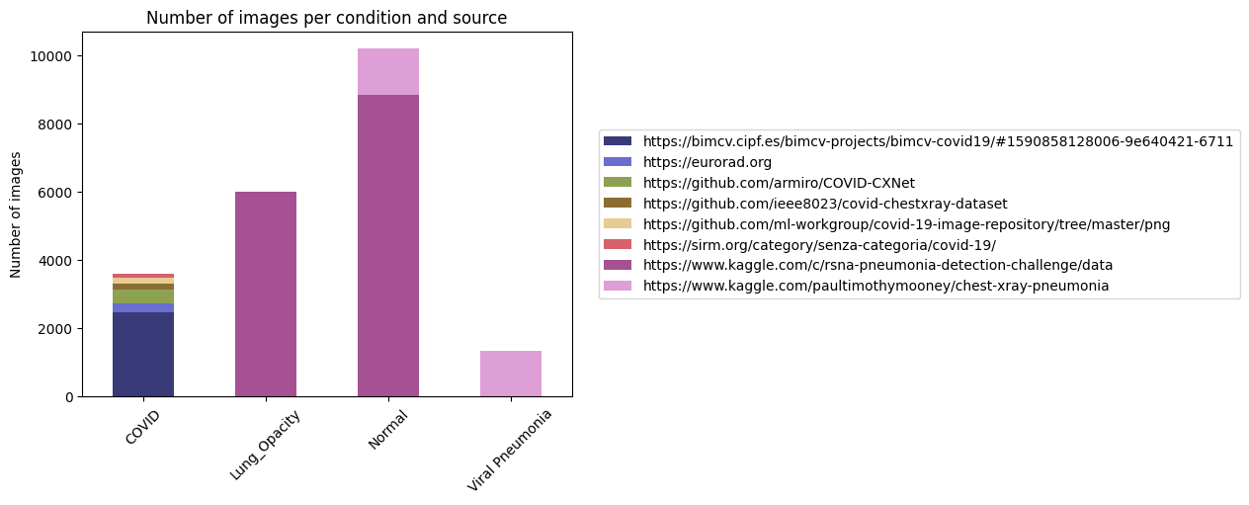

- Grayscale or color image

In this section we will analyze if the provided images are colored or grayscale images. When reading images, the resulting array had a shape of (299,299,3), although the images appeared to be grayscale. Reading the files as grayscale images would save computational capacity, however this would potentially reduce the informational content that three channels could provide. In order to decide if we are dealing with grayscale images or if we need to work with coloured images, we compared the three different channels of each image prior to any normalization. If the three channels are identical, we can conclude that these images are truly grayscale images and loading them as such will not result in a loss of information, but in an increase in performance.
For all images of the dataset, we found that the three channels are identical (Figure 4.1). Hence, images will be handled as grayscale images for efficiency.

Figure 4.1: Exemplified chest X-ray image split into its three channels and depicted as a grayscale image. The summary of the identity check for all images is shown below the images.

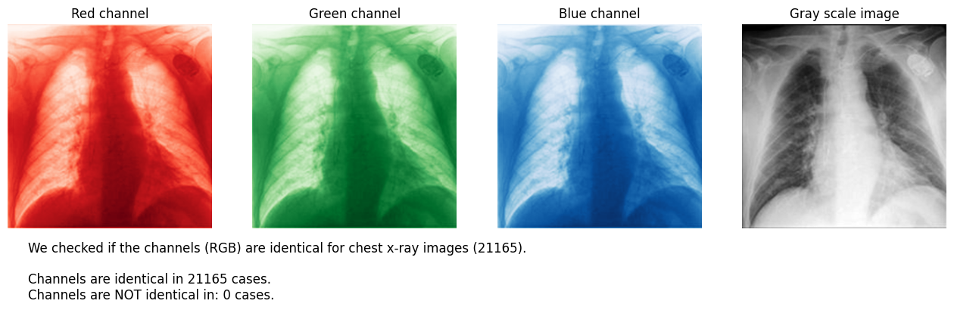

- Metadata check Image quality across sources

In this step, it was examined whether the X-ray images differ in terms of their source. First, it was investigated whether there is a systematic difference in the coloring of the images. In another step, it was analyzed whether there is a systematic difference in terms of the size of the lungs (differences in pixel count of the masked images), possibly caused by the use of different devices to create the images.

5.1. Analysis

For the analysis, statistical variables were first determined for each image, specifically pixel count, mean, standard deviation, minimum values, maximum values, median, 25th quartile, 75th quartile, as well as skewness and kurtosis of the respective histogram. For the first part of the analysis, which focuses on the systematic differences in coloring, these variables are based on the entire image, not just the masked area. This decision was made to minimize the influence of different cases on the evaluation. The distribution and proportion of sources per case vary significantly. By using the entire images, the consistent proportion across all images is significantly larger (approximately 60 - 75 %). For the second part of the analysis, the same variables were determined, but only for the masked area, i.e., the lung region.

To decide which variables to use for the analysis, a correlation matrix was first created with the goal of excluding strongly correlated variables from the analysis. Based on this, the median, 25th quartile, and 75th quartile were excluded due to their strong correlation with the mean value (Figure 5.1).

Figure 5.1: Correlation matrix of all statistical variables
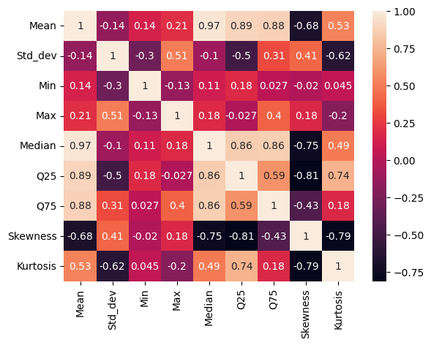
The remaining variables were visualized using boxplots to determine through visual inspection whether images from certain sources differed from those of others. Although minor differences were observed between different sources for the parameters min, max, kurtosis, and skewness, no clear patterns emerged across these parameters, such as a specific source consistently deviating in all or many parameters. However, for the variables mean and standard deviation, a noticeable deviation in distribution was observed for sources seven and eight. This is illustrated in the following figure. Therefore, the analysis will focus exclusively on the variables mean and standard deviation.

Figure 5.2: Boxplots that illustrate the distribution of mean values and standard deviations per source
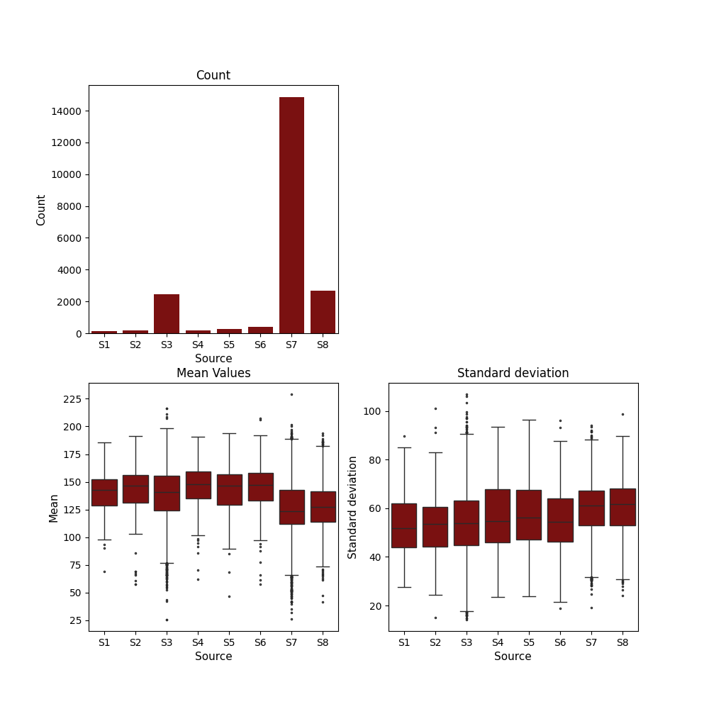

Since the number of images per source varies greatly, the minimum number of images per case (119) was set as the sample size for all other sources. This means that for all sources with more than 119 images, a random selection of 119 images was made. This selection of images (119 per source) will be used as the basis for further analysis.

Figure 5.3: Number of images per source (minimum number highlighted in red)
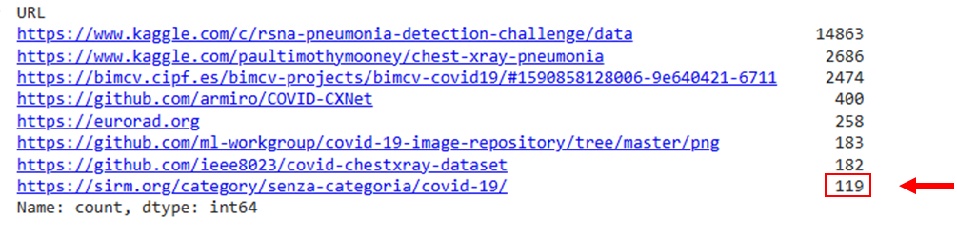
To analyze the relationship between the categorical variable source and the quantitative variable mean, we applied an ANOVA (Analysis of Variance) test. ANOVA is a statistical method used to compare the means of three or more groups to determine if at least one group mean is significantly different from the others. To conduct an one-way ANOVA analysis, the following conditions should be met: the observations must be independent, the data within each group should be approximately normally distributed, and the variances within the groups should be roughly equal. We assume that the X-ray images are independent of each other, meaning that the value of one image does not influence the value of another. In addition, the boxplots (Figure 5.2) show that the widths (IQRs) and ranges of the boxes are roughly similar across groups, this suggests that the variances are likely homogeneous. We therefore opted against a more rigorous assessment.
To check for normal distribution we visually inspected QQ-plots. The data, divided by source, were examined for normal distribution. QQ-plots were created and visually inspected for all sources and variables. Based on this, it was concluded that the data approximate a normal distribution for all cases (source x variable) (Figure 5.4).

Figure 5.4: Exemplary QQ-plot for source 1 (S1) and the variable mean
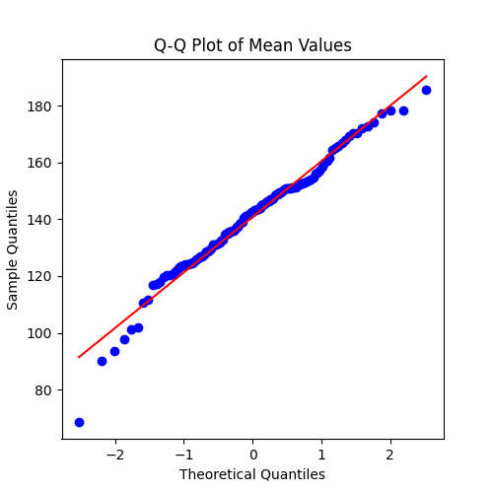
For the ANOVA analysis, we propose the following hypotheses:
Null Hypothesis (H0): Assumes that all group means are equal.
Alternative Hypothesis (H1​): Assumes that at least one group mean is different.
The ANOVA analysis was conducted using the library ‘statsmodels’, which delivered the following results:
Table 5.1: Results ANOVA I
Continuous variable | p-value
Mean | 3.048018e-16
Standard deviation | 0.000129

In the second step, it was investigated whether the size of the displayed lungs (corresponding to the pixel count per image) differs between sources. The same approach was used as for examining differences in coloring. The following figure shows the distribution of pixel counts for the different sources.

Figure 5.5: Boxplots that illustrate the distribution of pixel counts per source

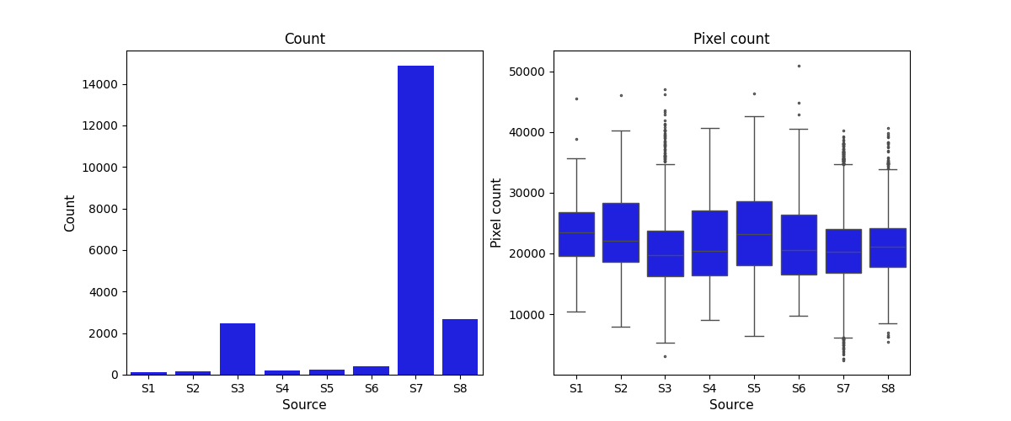
We see that, just as in the previous example, the conditions for ANOVA are considered to be met. Furthermore, the hypotheses align with those previously presented. The results are displayed in the following table.

Table 5.2: Results ANOVA II

Continuous variable | p-value
Pixel count | 0.000005

5.2. Interpretation

Considering a significance level of 0.05 we found a significant difference in mean (p < 0.05) regarding the mean values, standard deviations and pixel counts of the images from different sources. That means that the mean values of at least one source are significantly different from the mean values of images from other sources.

In comparison to before, normalization (min-max normalization) resulted in larger p-values. Nevertheless, the p-values remain well below 0.05 for all considered variables (see Table 5.3). Based on that, we conclude that the different image sources affect the optical properties and that normalization of pixel values slightly reduces these differences. Therefore, we believe that normalizing the pixel values represents a good preprocessing step.

Tabelle 5.3: Results ANOVA after pixel value normalization
Continuous variable | p-value (before) | p-value (after)
Mean | 3.048018e-16 | 8.920901e-13
Standard deviation | 0.000129 | 0.000234
Pixel count | 0.000005 | 0.000146

- Descriptive statistics between classes

This section extracts descriptive statistics from the images in order to compare the pixel distributions across the four classes: COVID, normal, lung opacity and viral pneumonia.

In order to compute descriptive statistics, we first flatten each image of dimension 299x299x3 into a single vector and standardize the pixel value to range between 0 and 1 to improve interpretability. Then, we calculate the respective descriptive statistics for each flattened pixel vector for all images categorized into the four classes. In particular, we are looking at mean, standard deviation, kurtosis and inter quartile range of the pixel values for each image.

We structure the code by computing the descriptive statistics right after flattening the pixel value of each image. Then, we accumulate data as a list of lists using the append function. Finally, a pandas DataFrame is created from this list of lists to construct histograms. This procedure allows for a lighter data structure than similar functions from pandas or numpy, in order to reduce memory usage and improve efficiency of the code.

Figure 6.1 plots the histogram of mean pixel values for the four classes. We can see that the distribution of the pixel means is more right skewed for the COVID class than for the normal and lung opacity class. Moreover, the highest modality of the mean pixel value of the COVID class is around 0.6, and therefore higher than for normal cases (0.45), lung opacity (0.45) and viral pneumonia (0.5). Thus, the distribution of the mean values looks more similar for the classes normal and lung opacity, while viral pneumonia and covid have different distributions of mean pixel values.

Figure 6.1: Histogram of mean pixel values
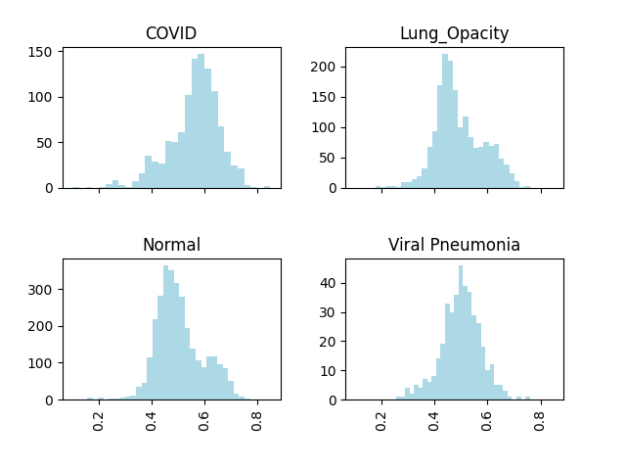
Figure 6.2 plots the histogram of the standard deviation of the pixel values for each of the four classes. It shows that the standard deviation of the pixel values is more spread out for the COVID class than for the normal, lung opacity and viral pneumonia class. The highest modality of the standard deviation of the pixel value of the COVID class is around 0.2, and therefore lower than for normal cases (0.25), lung opacity (0.25) and viral pneumonia (0.25). The distribution of standard deviations is most similar between normal and viral pneumonia, while COVID and lung opacity appear more distinct.

Figure 6.2: Histogram of standard deviation of pixel values
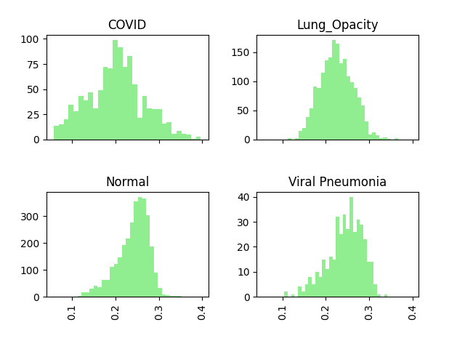
The histogram of the inter quartile range (IQR) of pixel values is shown in Figure 6.3. We can see that the highest modality for IQR is lowest for COVID and lung opacity at around 0.25. While the highest modalities for normal cases and viral pneumonia are each around 0.4. This implies that the pixel values for COVID and lung opacity are more concentrated around the median compared to the classes normal and viral pneumonia.

In sum, from the mean and standard deviation of the pixel values we can see that the distributions for COVID are most distinct. While the respective distributions for normal and viral pneumonia look more similar. The strongest similarity is between the distributions of lung opacity and normal cases. Therefore, we expect the model to be best at predicting COVID classes while it should be more difficult for the model to differentiate between normal and lung opacity cases.

Figure 6.3: Histogram of inter quartile range of pixel values
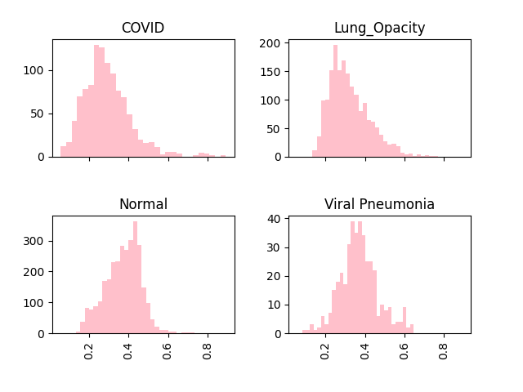

- Exploring image pre-processing options
In this section, a potential image preprocessing approach is explored, which could be applied to the images before modeling, with the possible goal of improving modeling results. The preprocessing approach consists of converting to grayscale, masking the images, normalizing pixel values, applying filtering to reduce noise, and applying a contrast enhancement technique to the images.
Converting to grayscale: Converting X-ray images to grayscale is helpful because it aligns with the nature of the images (represent variations in intensity rather than color) and reduces the computational burden of preprocessing and analysis. See also section 4.
Masking of images: Masking X-ray images to the lung area enhances the focus on the relevant region affected by COVID, which most likely improves the accuracy and efficiency of the analysis. In addition, it reduces computational load. For machine learning models, training on masked images can enhance performance by ensuring the model learns only from relevant features (associated with the disease). The masking was performed using the masks associated with the dataset. The masks were resized to fit the shape of the X-ray images (299 x 299) using linear interpolation. The resized mask was then applied to the image using a bitwise AND operation. For both operations available methods from the cv2 library were applied (cv2.resize, cv2.bitwise_and).
Normalizing pixel values: Normalizing pixel values to scale image data can improve the performance and stability of image analysis and machine learning algorithms. Here, we applied min-max normalization to the pixel values. The goal of this normalization is to rescale the pixel values to a consistent range, [0, 1], which helps in standardizing the image data and reducing the impact of varying intensity levels.
Noise reduction: Noise reduction is often applied for X-ray image analysis to improve image quality, and thus model performance. The reduction of random variations and artifacts helps in obtaining clearer images. There are different techniques to reduce the noise of an image, such as Gaussian filtering, median filtering, bilateral filter and non-local means denoising. Here, we applied Gaussian filtering, which smoothes an image as weighted by a Gaussian kernel and the set standard variation. The kernel size was set to 3 x 3. The standard deviation was set to 0, meaning it is calculated based on kernel size. The small kernel size results in only a very soft smoothing. Larger tested kernel sizes (5 x 5) seemed to smooth the images too much, resulting in blurring of fine structures. The application of non-local means denoising with standard settings (h = 5, templateWindowSize = 7, searchWindowSize = 21) also led to an increase in blurring of fine structures. Overall, the images appear to be of fairly good quality already. This assessment is based solely on visual inspection though.
Contrast enhancement: Contrast enhancement aims at improving the visibility of important features, in this way subtle and critical features become more distinct. There are different techniques to enhance the contrast of an image, such as histogram equalization, contrast limited adaptive histogram equalization, and Gamma correction. Here, we applied histogram equalization, which redistributes the intensity values of pixels, aiming at spreading out the most frequent intensity values to enhance the contrast of the image.

The following figure displays the explored preprocessing steps for one image of each case.
Figure 7.1: Tested preprocessing steps for one image of each case
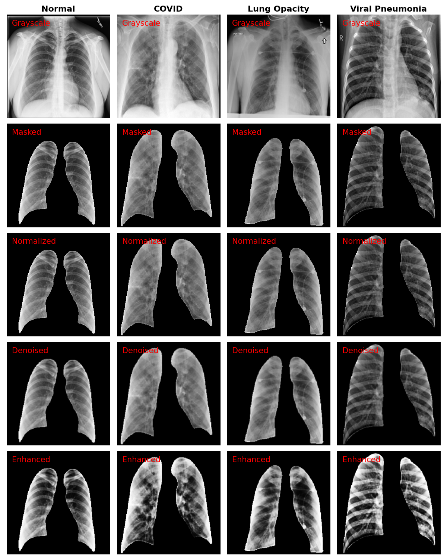
A visual inspection of the images, as shown in Figure 7.1, reveals that the contrast enhancement step, in particular, makes the structures somewhat more pronounced. Whether this ultimately leads to an improvement in model performance is difficult to determine and would require further statistical evaluations.

In sum, it can be said that converting to grayscale, masking the images, and normalizing the pixel values seem to be useful preprocessing steps. Further preprocessing steps could be tested for specific models.

- Conclusion

- The formal quality of the images is good, as no corrupt images have been found and both labels and sizes were correct and consistent. However, a few duplicate images have been found and will be removed. Moreover, we found that the three color channels are identical for all images. We will therefore handle the images as grayscale images for efficiency.
- From the descriptive statistics of the pixel values, we expect the model to be best at predicting COVID classes; while it should be more difficult for the model to differentiate between normal and lung opacity cases. This will be taken into account in the modeling section.
- However, the analysis has shown that the optical properties of the images appear to vary depending on the source. Normalization seems to slightly reduce these differences. Yet, a potential bias depending on the image quality by source remains to be taken into account.
- Based on these assessments, converting to grayscale, masking the images and normalizing the pixel values appear to be useful preprocessing steps. Additional preprocessing options could have a positive effect on model performance.
- We remain open to testing whether certain models achieve better results when preprocessing operations of this type (such as noise reduction and contrast enhancement) are applied. This is likely also dependent on the type of model used and its specific requirements and characteristics.

